**Website Changes**

**HOME Main Screen 3 hous**

Website page: <http://www.internationalsimulationalliance.com/home>

Can you redirect to this page?: <http://www.internationalsimulationalliance.com/user>

The former home page can be hidden at this stage.

I have set up an example below to show you what we want to allow access below in the visual.

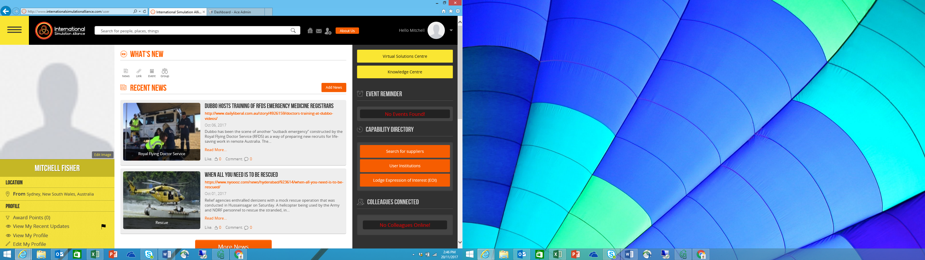

Where it says ‘MITCHELL FISHER’ under the profile photo, can you please change it to the ‘JOIN AS FREE SUBSCRIBER OR LOGIN’, then take them to: <http://www.internationalsimulationalliance.com/home/landing>

**Bottom Links**

At the bottom of the site can you make the following links hidden as we have no content yet:

* Press
* Blog
* Careers
* Tools
* Mobile
* Community

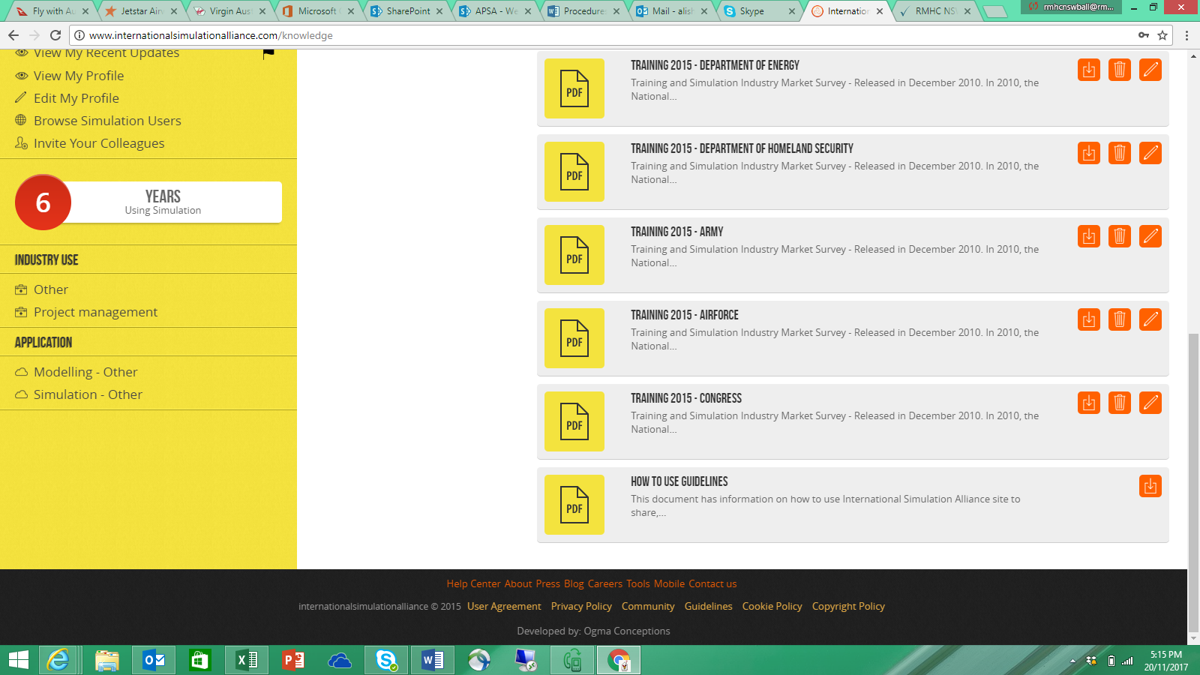

**Knowledge Centre Page Changes**

Website link: <http://www.internationalsimulationalliance.com/knowledge>

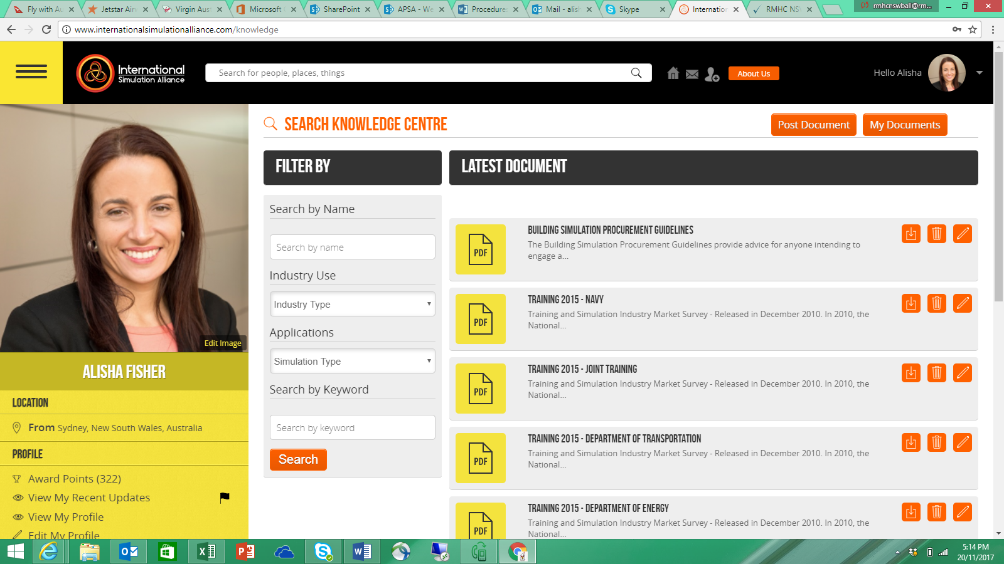

Can you add a link at the top saying ‘Share Video’ next to the ‘post document’ button?

We want to enable videos to be posted to be downloaded. These need to be mp4 files.

**2 hours**

Can you make sure it appears in the ‘knowledge centre’ management in the admin portal for us to remove inappropriate videos?

**1 hour**

When the person clicks ‘My Documents’ we want them to see all their documents uploaded and their videos uploaded. **2 hours**

**Groups 2 hours**

Website Link: <http://www.internationalsimulationalliance.com/group/show_group>

When we click into the group, can you activate the ‘blog’, ‘events’, and ‘video’ buttons to appear at the top with the news, link, event and group?

We want group members to be able to add events relevant to their group.

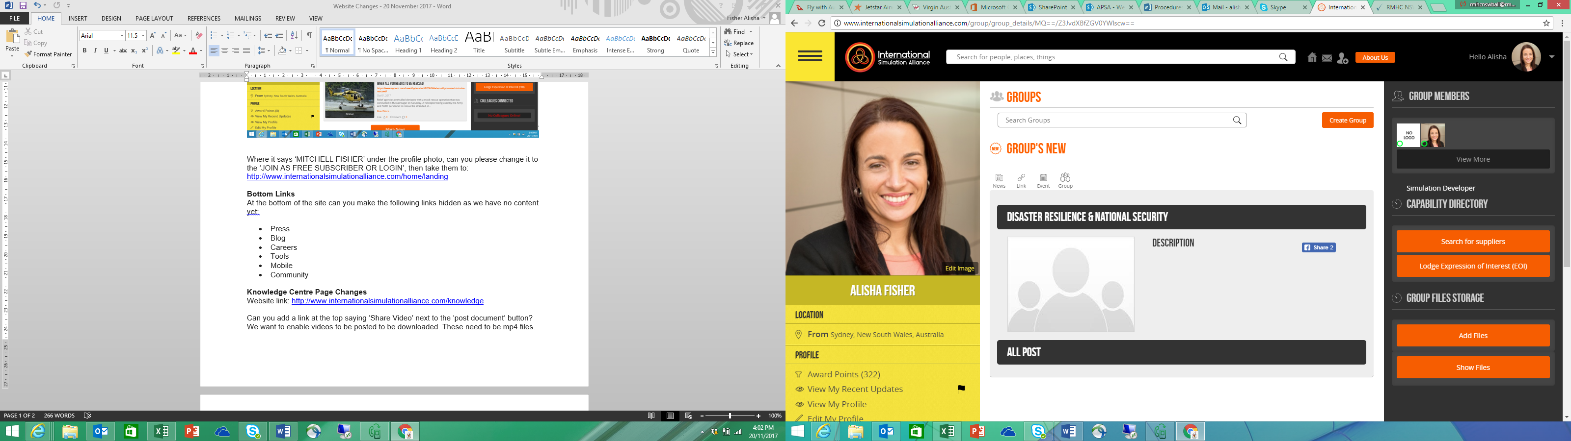

**Admin Portal**

**Advanced Master 3 hours**

Can you add ‘Click here page link name’ like the ‘Apsa Events’ pages?

We want to again direct them to the static pages created.

**NEW Static Pages**

Can you create 4 new static pages?

* CivSec
* Pacific
* LandForces
* Avalon